Pop up drill / communication

Objective
- The purpose of this drill is to develop communication and overall ball awareness between infield and outfield players.

Equipment
- Baseballs (5-10)
- Gloves
- Fungo (optional
- Pitching Machine (optional)

Description
- Divide players into two lines (one line standing in left field, the other at shortstop) and hit fly balls between them. Their job is to decide who is going to make the catch and who is going to cover.
- After each hit, have players rotate to the end of opposite lines. For example, player 1 switches to the end of the line that player 2 came from.

Tips
- For younger, inexperienced players, simply throwing a ball in the air between the fielders may work better.
- Explain to players that it is always the infielder's ball until the outfielder calls them off.
- Always remind players "off the ball" to back up their teammate making the catch.
- Access to pitching machines can be effective because of the consistency of quality fly balls to the fielders.

Fly from behind drill

Objective
- Develop players' reaction time and ball awareness.
- Develop communication between fielders.

Equipment
- Baseballs (1-4)
- Pitching Machine (optional)
- Glove

Description
- Have player(s) start from a kneeling position facing away from the coach.
- After the coach throws a fly ball directly above the player(s) kneeling, coach yells, "ball."
- The player then gets to a standing position and turns to pick up the fly ball.
- The fielder's job is to get under the ball as quickly as possible and catch it using the proper fielding technique.

Tips
- This drill can also be done in groups of two or four.
- As the coach, throwing the ball into the air is optional. The drill is also effective if the ball is placed in a pitching machine that is tilted to shoot high pop ups.
- Whichever technique is used will determine how far a coach needs to be from the player receiving the ball.

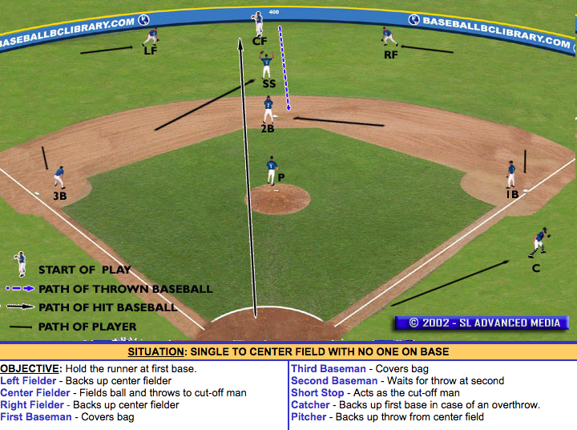

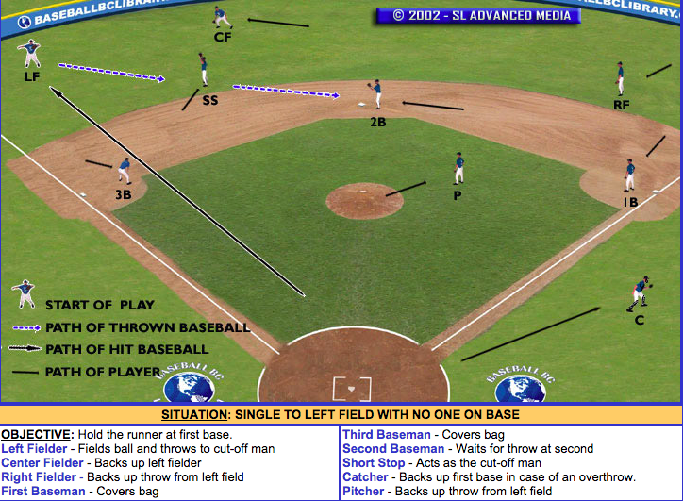

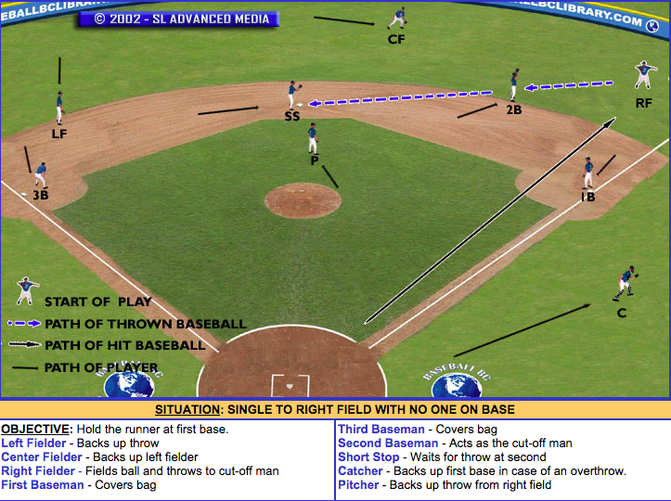

4 Corners drill

5 players

Make a square approx. 20 feet apart

1 player at each corner cone and one in the middle

Have each player throw a different ball to player in middle and player throws back to that corner

Grounder, line drive, long hop, short hop

Middle player Cycles through each corner then switches with first corner until all players have a turn in the middle

